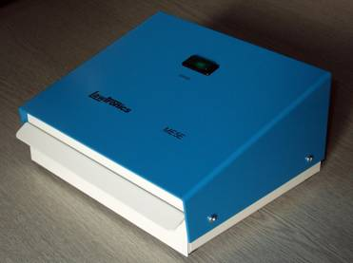

Model ME5E Eprom Eraser

General Specification

The ME5E Eprom eraser is a robust bench top unit designed for simple low-volume applications requiring controlled UV exposure. This eraser is constructed to operate consistently and reliably over a long life. The ME5E incorporates advanced features to ensure dependable erasure and operator safety. A safety interlock prevents any UV leakage and the filtering action of the quartz glass tube minimises ozone separation. A panel indicator shows the erasing cycle and the sample tray is designed for on-board erasing.
The UV wavelength of 253.7nm at initial exposure levels of 4000 µW/cm² ensures complete erasure in typically 15 minutes, or less, for new lamps. The ME5E unit is designed to operate from 230V at 50Hz. At slightly lower voltages, satisfactory operation is achieved with slightly extended exposure time proportional to the voltage reduction.
Standard Features
Exposure Tray: Safety interlocked, capacity 150 x 60 x 20mm

On Board Erasure: Capacity 5 Eproms of 28-40 pins on anti-static foam

Indicator Lamp: Erase on

UV Lamp: Fitted with 1 lamp, nominal 4000 µW/cm²

Power Input: IEC Connector for 230V at 50Hz AC

Input Cable: Supplied with moulded 1.8m UK/Euro mains to IEC cable

Dimensions: 190w x 165d x 95h mm

Mass: 2kg

Consumable Items

Spare UV Lamps: Model G4T5 for ME5E and ME5

Model G8T5 for ME15, ME30, ME90

Model G15T8 for ME200

